CTCS | 
 | Product Documentation

TS Tamarai Selvan

Harsha S

Table of Content
- Introduction
  - Brief Overview of the product
  - Purpose and scope of the product

- Getting Started
  - System Requirements
  - Installation Instructions

- User Interface
  - Overview of the User Interface
  - Navigation
  - Key features and functions

- Maintenance and Updates
  - Regular Maintenance tasks
  - How to update the product

- Support and Resources
  - Contact Information for support.

Introduction

This is a software product which is a cutting-edge Windows service solution designed to empower administrators with critical and specific system information at their fingertips.

Our robust solution provides seamless recording, storing, and classifying essential data, revolutionizing the way you manage and control the system infrastructure.

This Product is intended to ease the administrators work on maintain the systems in the organization. The product records and accumulates several critical data of the system such as: WIFI connected, Public IP, Private Ip, Host name, Serial Number, Application installed information and display that in an easily assessable Web interface. The details which are retrieved from the system are processed in several ways and displayed in the database.

Get Started
- System Requirement:

The minimum system information for installing the service only needs (x64/x86) systems. It can work with very little memory.

The Web server minimum requirement is dependent upon the usage and average read and write operation performed per day.

- Installation Instructions:

Firstly, the windows service to be installed in the client systems. Then once the system restarts your good to go. The service will record the data and send it to the database through the secure channel.

Secondly the Web Server needs to be configured with nginx Web Server installed and the website deployed into the web server in which the website is connected to the online MySQL Database.
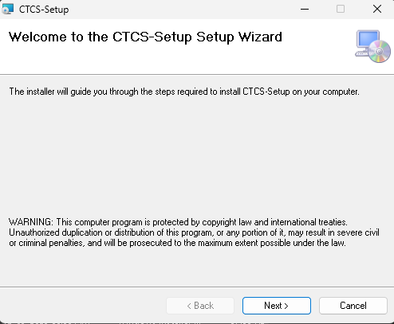

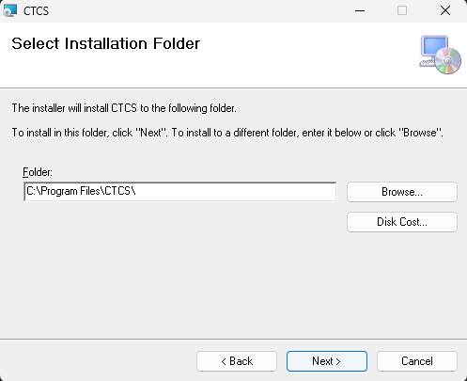
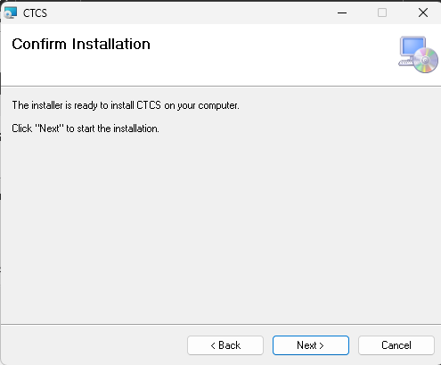

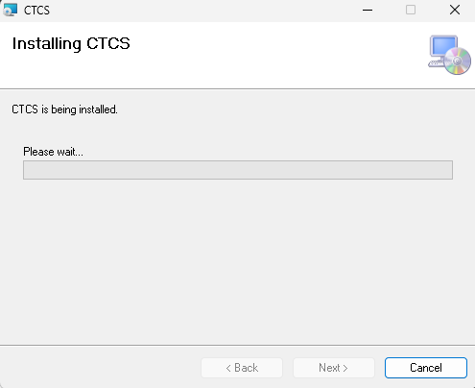
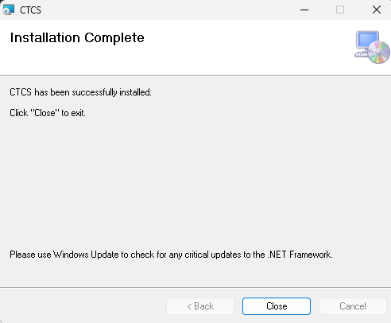

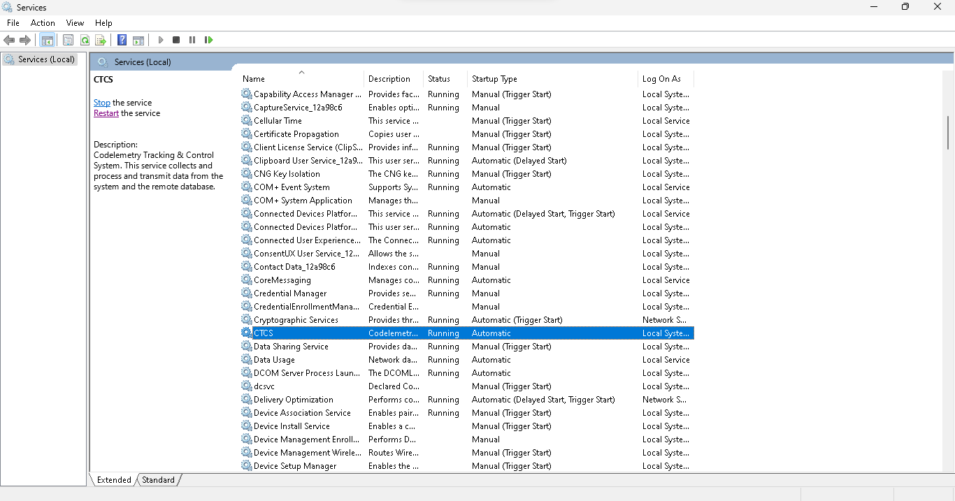

User Interface

The Data which is recorded from the Windows service is stored in the MYSQL Database and which is accessible through a graphical web-based interface.

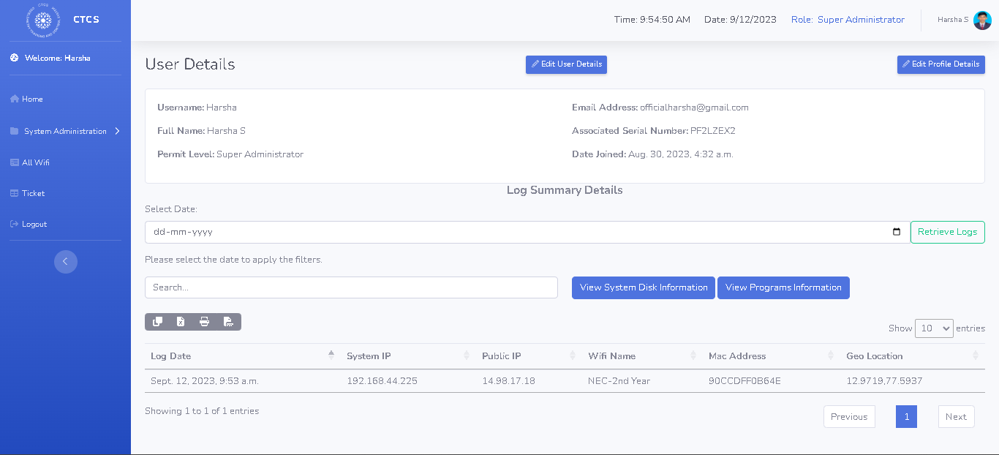

The navigation system of the website is a very easily understandable menu navigation item.

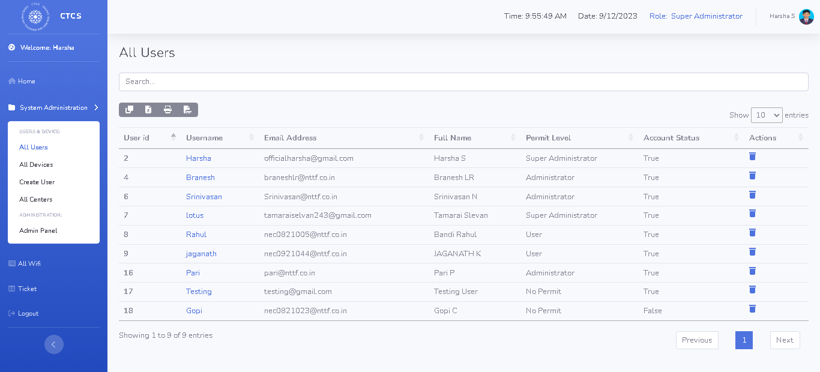

These are the list of Key Features and Functionalities

- Service will record and transfer major critical information to the database.
- Authentication system on service installation.
- Authentication and Authorization to the website.
- Graphical Dashboards.
- User Management.
- Log Management.
- Disk usage management to appropriate users.
- Application installation information to appropriate users.
- Centers and WIFI Management.
- Device Management.
- Advanced filtration.
- Advanced table view to download, copy, print in instant data.
- Bulk import and export functionality.
- Ticket Management System.

Maintenance and Updates

Maintenance is taken care of by CTCS Team totally. Which includes the product maintenance and the user data maintenance. We are responsible for each user's problem and data privacy and integrity of data.

Updates to both website and Service will be taken care by CTCS Team

Support and Resources

Any issues in Application the issue can be raised. Or else If there is any upgrade requirement or else any major problem or anything. It can be communicated to the following email id:

TS Tamarai Selvan - tamaraiselvan@nttf.co.in
Harsha S – harsha@nttf.co.in

Elevate your system management game with CTCS Today!

